In argocd UI:
Settingconnect repo
- https
- type: helm
- name: helmrepo
- project: myproj
- helm url: https://charts.bitnami.com/bitnami

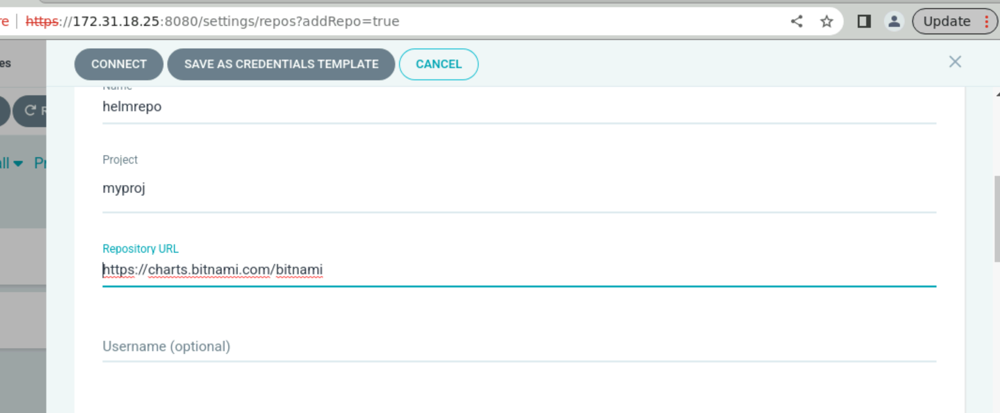

Map helm repo.

Create application type resource in UI

Sync: Automatic
Auto create namespace: true
Map source

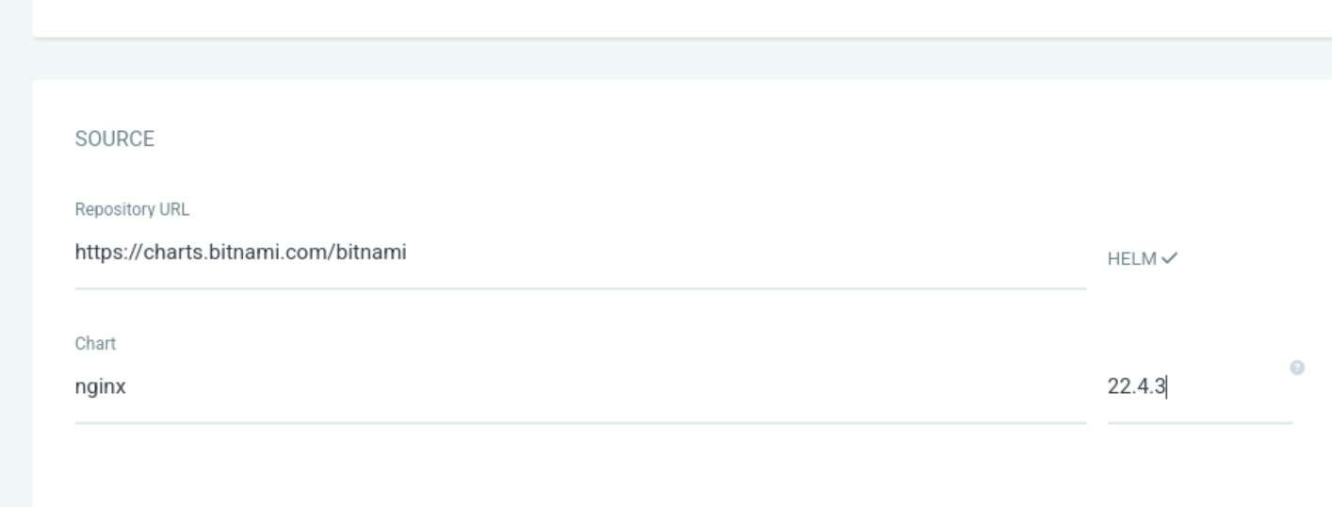

apiVersion: argoproj.io/v1alpha1
kind: Application
metadata:
name: myhelm proj
spec:
destination:
namespace: ''
server: https://kubernetes.default.svc
source:
path: ''
repoURL: https://charts.bitnami.com/bitnami
targetRevision: 22.4.3
chart: nginx
helm:
valueFiles:
- values.yaml
sources: []
project: myproj
syncPolicy:
automated:
prune: false
selfHeal: true
enabled: true
syncOptions:
- CreateNamespace=true

